1️⃣ What is Spring Framework?
🔹 Definition
Spring Framework is a lightweight, open-source Java framework used to build enterprise-grade, scalable, secure, and maintainable Java applications.
In simple words:
Spring helps you build Java applications faster, cleaner, and with less code.

🔹 Why Spring Was Introduced (The Problem Before Spring)
Before Spring, developers mainly used:
- Core Java
- J2EE (EJB, Servlets, JSP)
Problems:
- Heavy configuration (XML everywhere)
- Tight coupling between classes
- Difficult testing
- Boilerplate code
- Poor maintainability
Spring solved all these problems using IoC, DI, AOP, and modular design.

2️⃣ What Can We Perform Using Spring Framework?
Spring is not just one thing — it is a complete ecosystem.
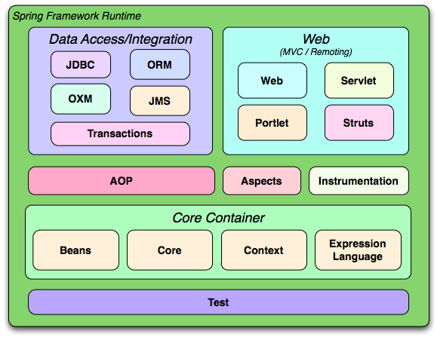
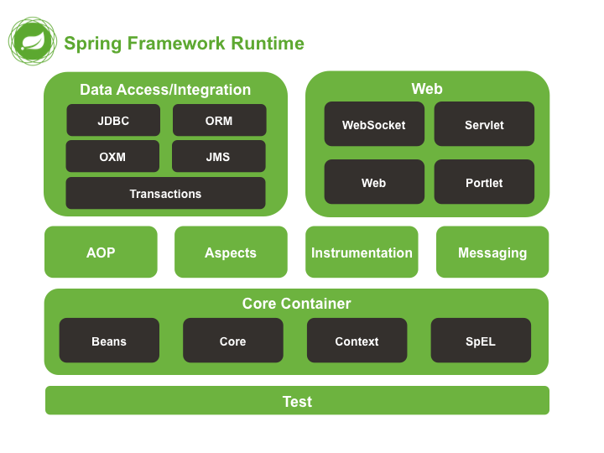
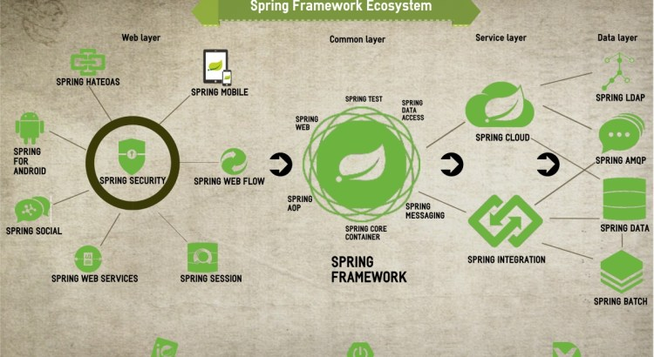
🔹 Major Things You Can Do Using Spring

✅ 1. Build Enterprise Java Applications
- Banking systems
- Insurance applications
- ERP systems
- E-commerce platforms

✅ 2. Dependency Injection (DI)
Spring manages object creation and dependency wiring.
❌ Old way (tight coupling):
Car car = new Car(new Engine());
✅ Spring way (loose coupling):
@Autowired
Engine engine;

✅ 3. Web Applications (MVC)
Using Spring MVC you can build:
- Web apps
- REST APIs
- Microservices
Example:
@GetMapping("/hello") // Rest API
public String hello() {
return "Hello Spring";
}

✅ 4. RESTful APIs
Spring is widely used to create:
- REST APIs
- JSON/XML services
- Backend for React / Angular / Mobile apps

✅ 5. Database Access & ORM
Spring integrates easily with:
- JDBC
- Hibernate
- JPA
- MyBatis
Example:
@Repository
public interface EmployeeRepo extends JpaRepository<Employee, Integer> {
}

✅ 6. Transaction Management
Spring provides declarative transaction management.
@Transactional
public void transferMoney() {
// business logic
}
No need to manually write commit/rollback logic.

✅ 7. Aspect Oriented Programming (AOP)
Used for:
- Logging
- Security
- Transactions
- Performance monitoring
Example:
@Before("execution(* com.service.*.*(..))")
public void logBefore() {
System.out.println("Method called");
}

✅ 8. Security
Using Spring Security, you can implement:
- Authentication
- Authorization
- JWT
- OAuth2
- Role-based access

✅ 9. Microservices
With Spring Boot + Spring Cloud:
- Config Server
- Service Discovery (Eureka)
- API Gateway
- Load Balancing
- Circuit Breakers

✅ 10. Testing
Spring supports:
- Unit testing
- Integration testing
- Mocking
Example:
@SpringBootTest
class EmployeeServiceTest {
}

3️⃣ Core Features of Spring Framework
Feature | Description
IoC | Inversion of Control
DI | Dependency Injection
AOP | Aspect Oriented Programming
MVC | Model View Controller
ORM | Database integration
Security | Authentication & Authorization
Transaction Mgmt | ACID compliant transactions
Modular | Use only what you need

4️⃣ Spring Framework Modules (High Level)
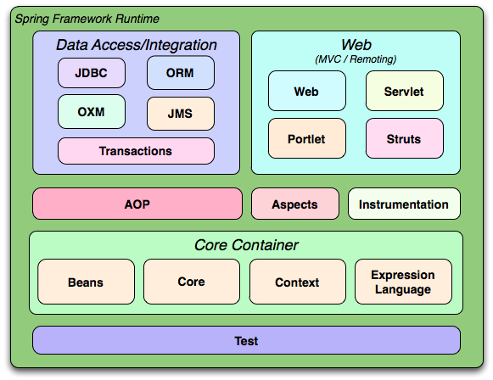
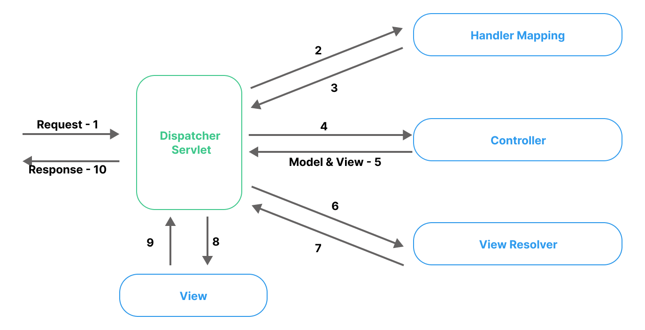
🔹 Important Modules
Module | Purpose
Spring Core | IoC, DI
Spring Context | Application context
Spring Beans | Bean lifecycle
Spring AOP | Cross-cutting concerns
Spring MVC | Web applications
Spring JDBC | Database access
Spring ORM | Hibernate/JPA
Spring Security | Authentication
Spring Test | Testing support

5️⃣ Different Versions of Spring Framework
Spring has evolved continuously over the years.
🔹 Major Version History
Version | Key Highlights
Spring 1.x | Initial IoC container
Spring 2.x | XML improvements
Spring 3.x | Annotation support
Spring 4.x | Java 8 support
Spring 5.x | Reactive programming, WebFlux
Spring 6.x | Java 17+, Jakarta EE

6️⃣ What is the Current Version of Spring Framework?
✅ Spring Framework 6.x (Latest Major Version)
- Current stable line: Spring Framework 6.1.x
- Requires Java 17 or above
- Fully supports Jakarta EE (jakarta. packages)*
📌 Important:
- javax.* → replaced by jakarta.*
- Mandatory for modern enterprise apps

7️⃣ Spring vs Spring Boot (Quick Clarity)
Spring Framework | Spring Boot
Configuration heavy | Auto-configuration
XML + Java config | Minimal configuration
Manual setup | Embedded server
Learning curve | Faster development
👉 Spring Boot is built on top of Spring Framework

8️⃣ Real-World Example Scenario
Banking Application
Spring helps with:
- DI → Inject services
- AOP → Logging & transactions
- Security → Login & roles
- ORM → Database operations
- REST → Mobile & web APIs

9️⃣ Why Companies Prefer Spring?
✅ Industry standard
✅ Huge community
✅ Excellent documentation
✅ Easy testing
✅ Cloud & microservice ready
✅ Backed by VMware / Broadcom
Used by:
- Banks
- Product companies
- Startups
- Government systems

🔟 Interview-Ready One-Liners
- Spring is a framework, not a language
- It promotes loose coupling
- Core principle: IoC & DI
- Spring Boot simplifies Spring configuration
- Spring 6 requires Java 17+

🧠 Summary (Trainer Note)
Spring Framework is the backbone of modern Java enterprise development.
If you know Spring well, you are job-ready in Java backend roles.

